WEEKLY ASSESMENT 2

**RENOLT TOM MANGALATH**

**VIT VELLORE**

20MID0030

1. Download the dataset: Dataset
2. Load the dataset.

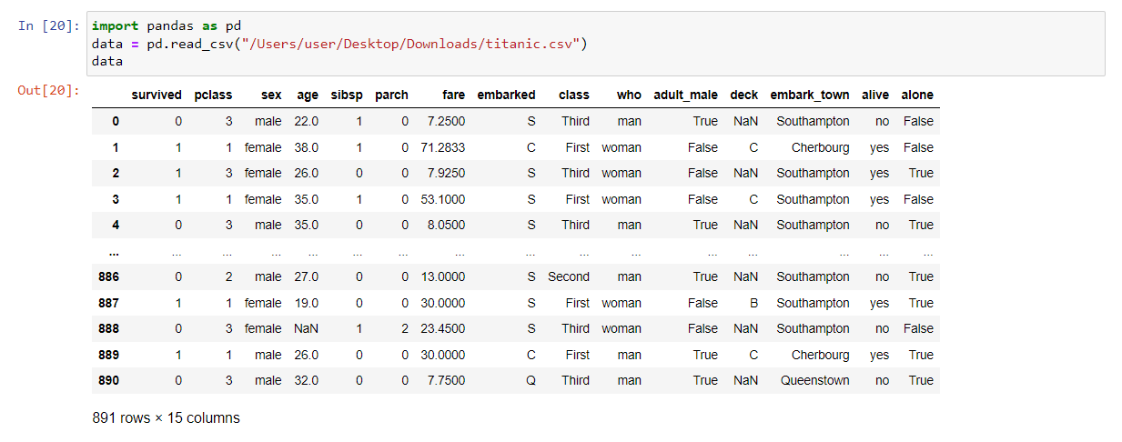

1. Perform Below Visualizations.

* Univariate Analysis

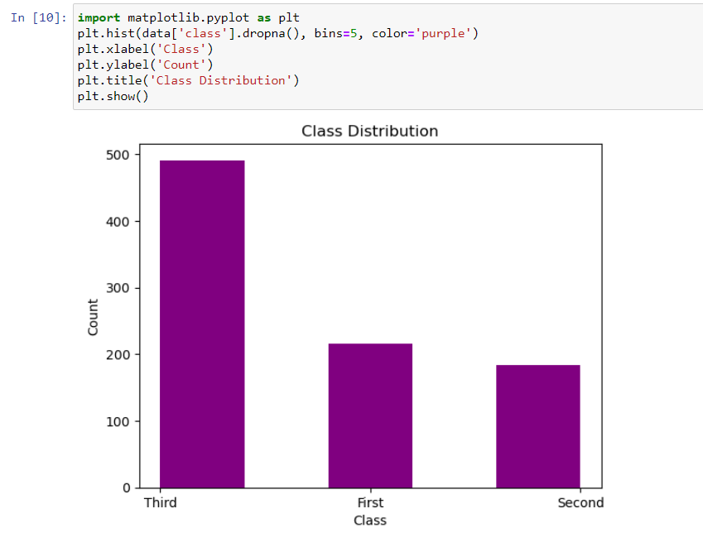

* Bi - Variate Analysis

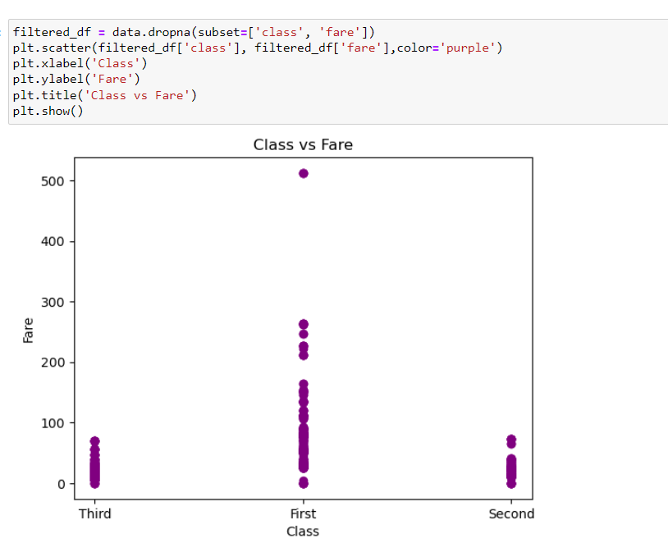

* Multi - Variate Analysis

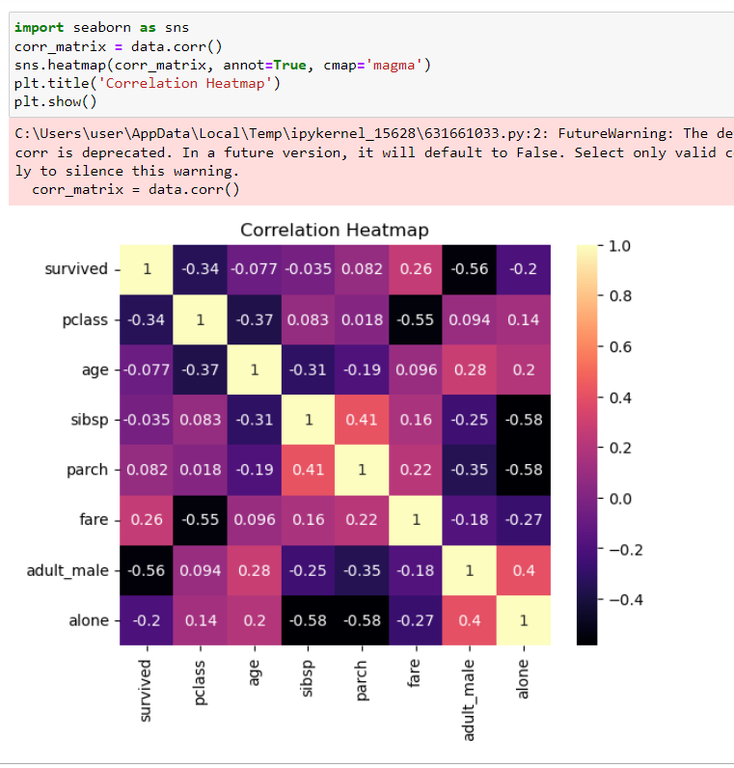

1. Perform descriptive statistics on the dataset.

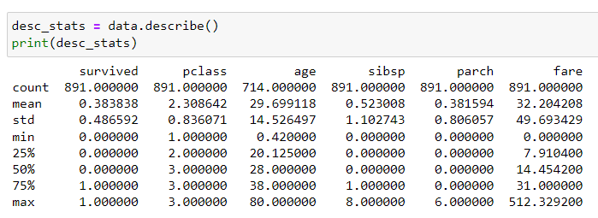

1. Handle the Missing values.

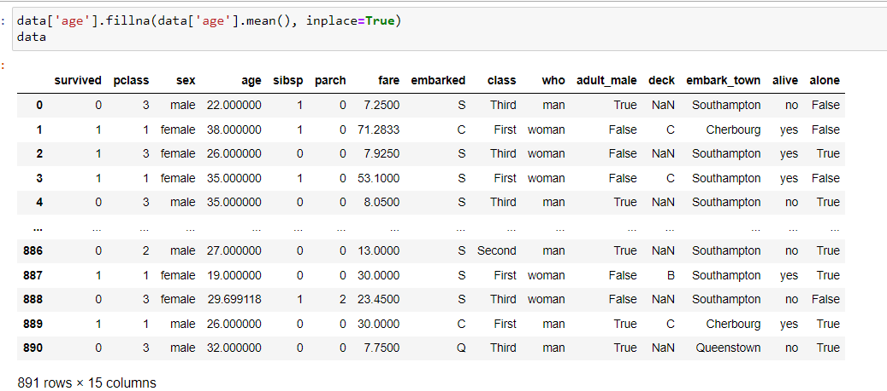

1. Find the outliers and replace the outliers

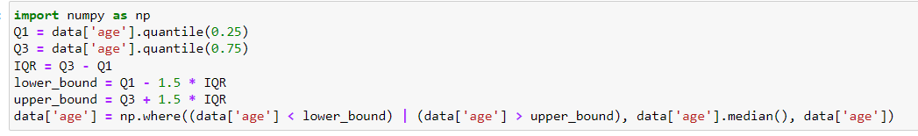

1. Check for Categorical columns and perform encoding.
2. Split the data into dependent and independent variables.
3. Scale the independent variables
4. Split the data into training and testing

